University of Technology, Jamaica

Faculty of Engineering and Computing

School of Computing and Information Technology (SCIT)

Module Name: Introduction to Human Computer Interaction

Module Code: 3023

Tutor: Nadine Maitland

.

**Authors:**

Jade Robinson -1701077

Michael Jones -1604149

Andre Cameron -1701496

Due Date: February 15, 2021

**Summary of the data gathered**

**Questionnaire**

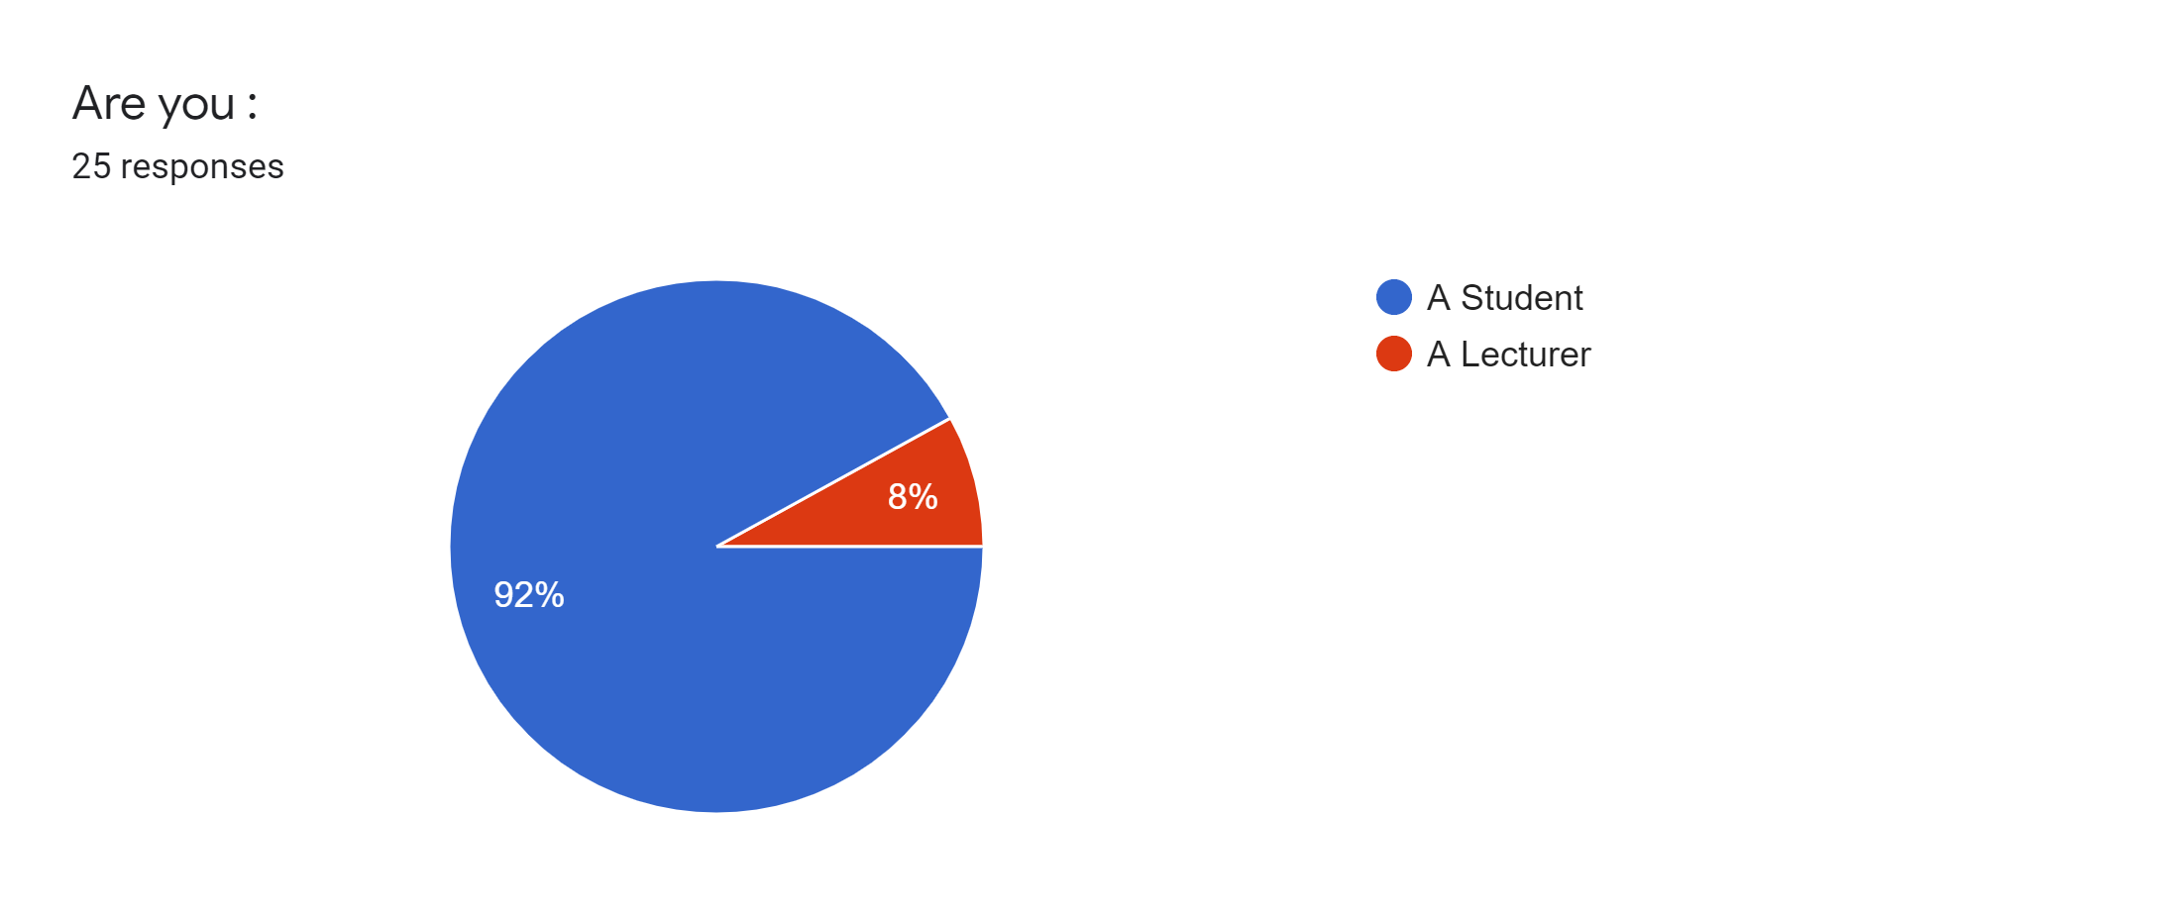

Concerning the surveys they were both conveyed by all gathering individuals, This poll comprises mostly understudies we have gotten 25 reactions 52% male and 48%are female, all both comprehensive of 92% students and 8% are teachers.

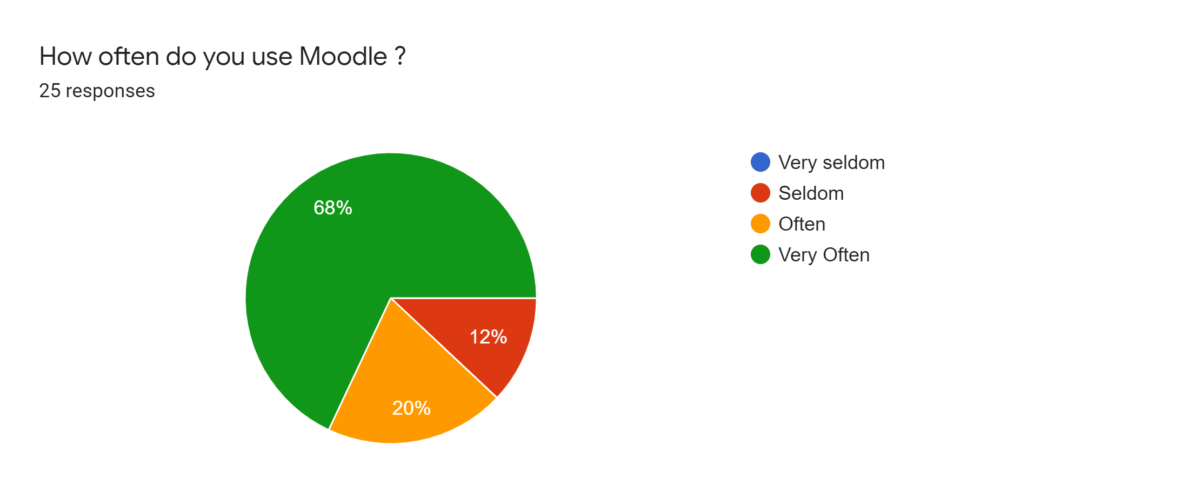

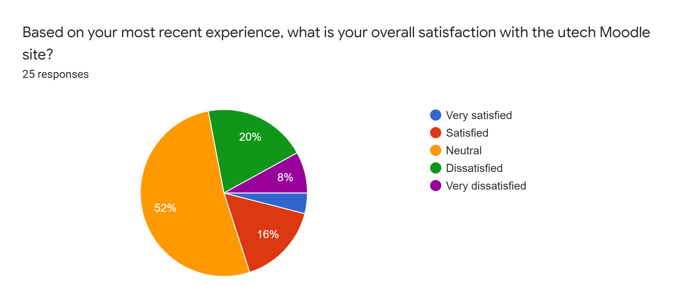

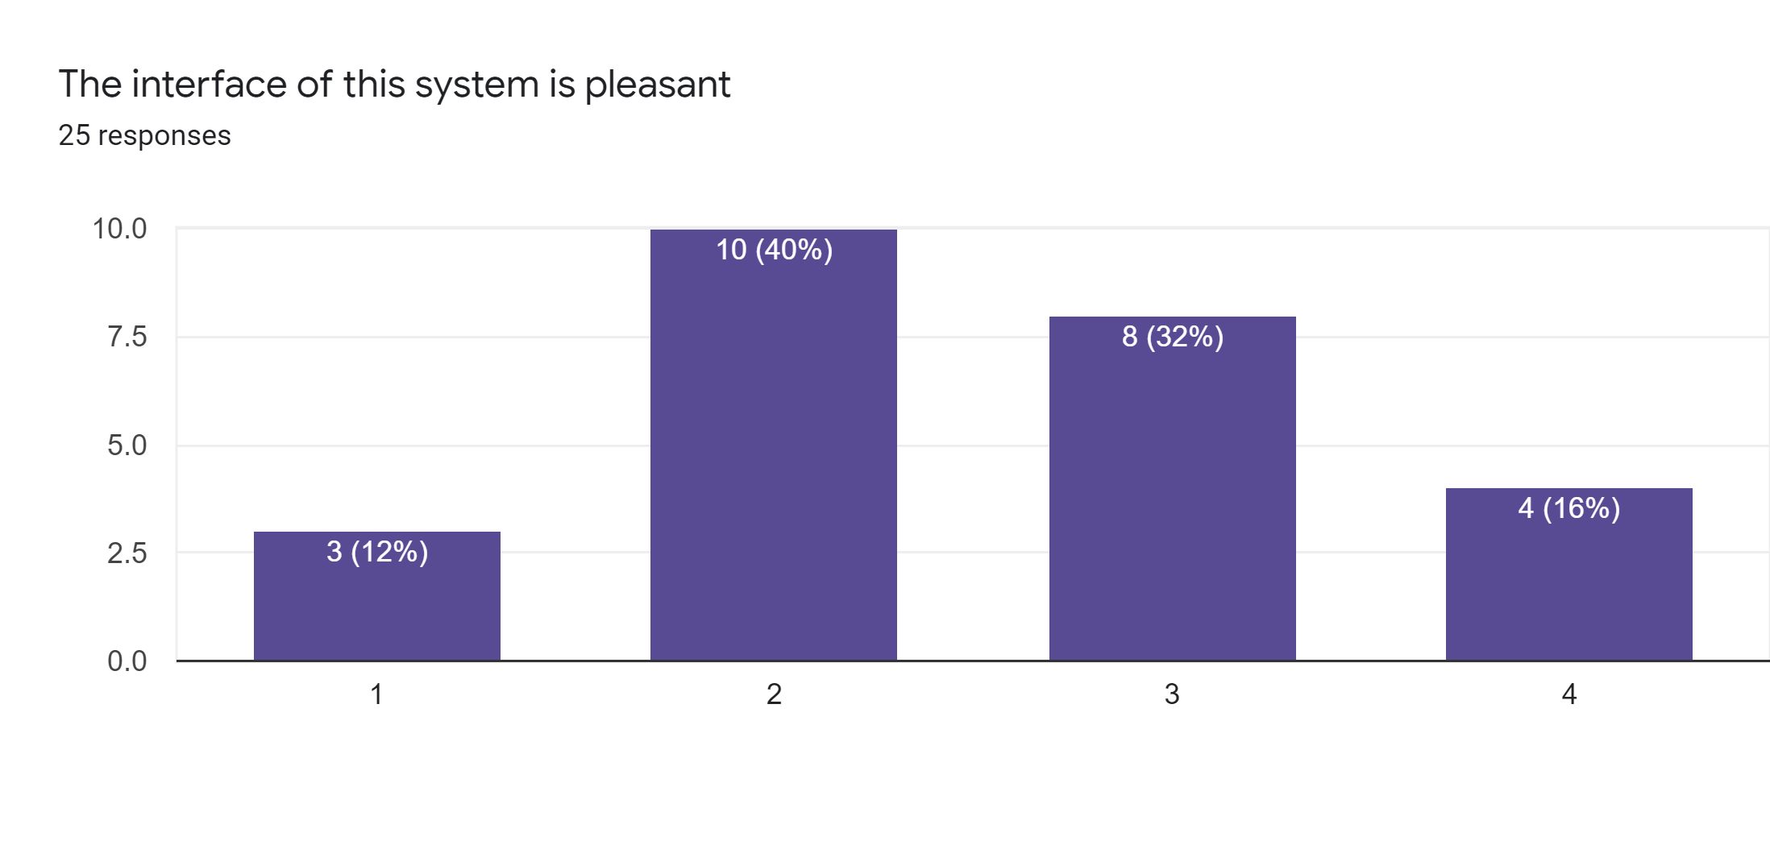

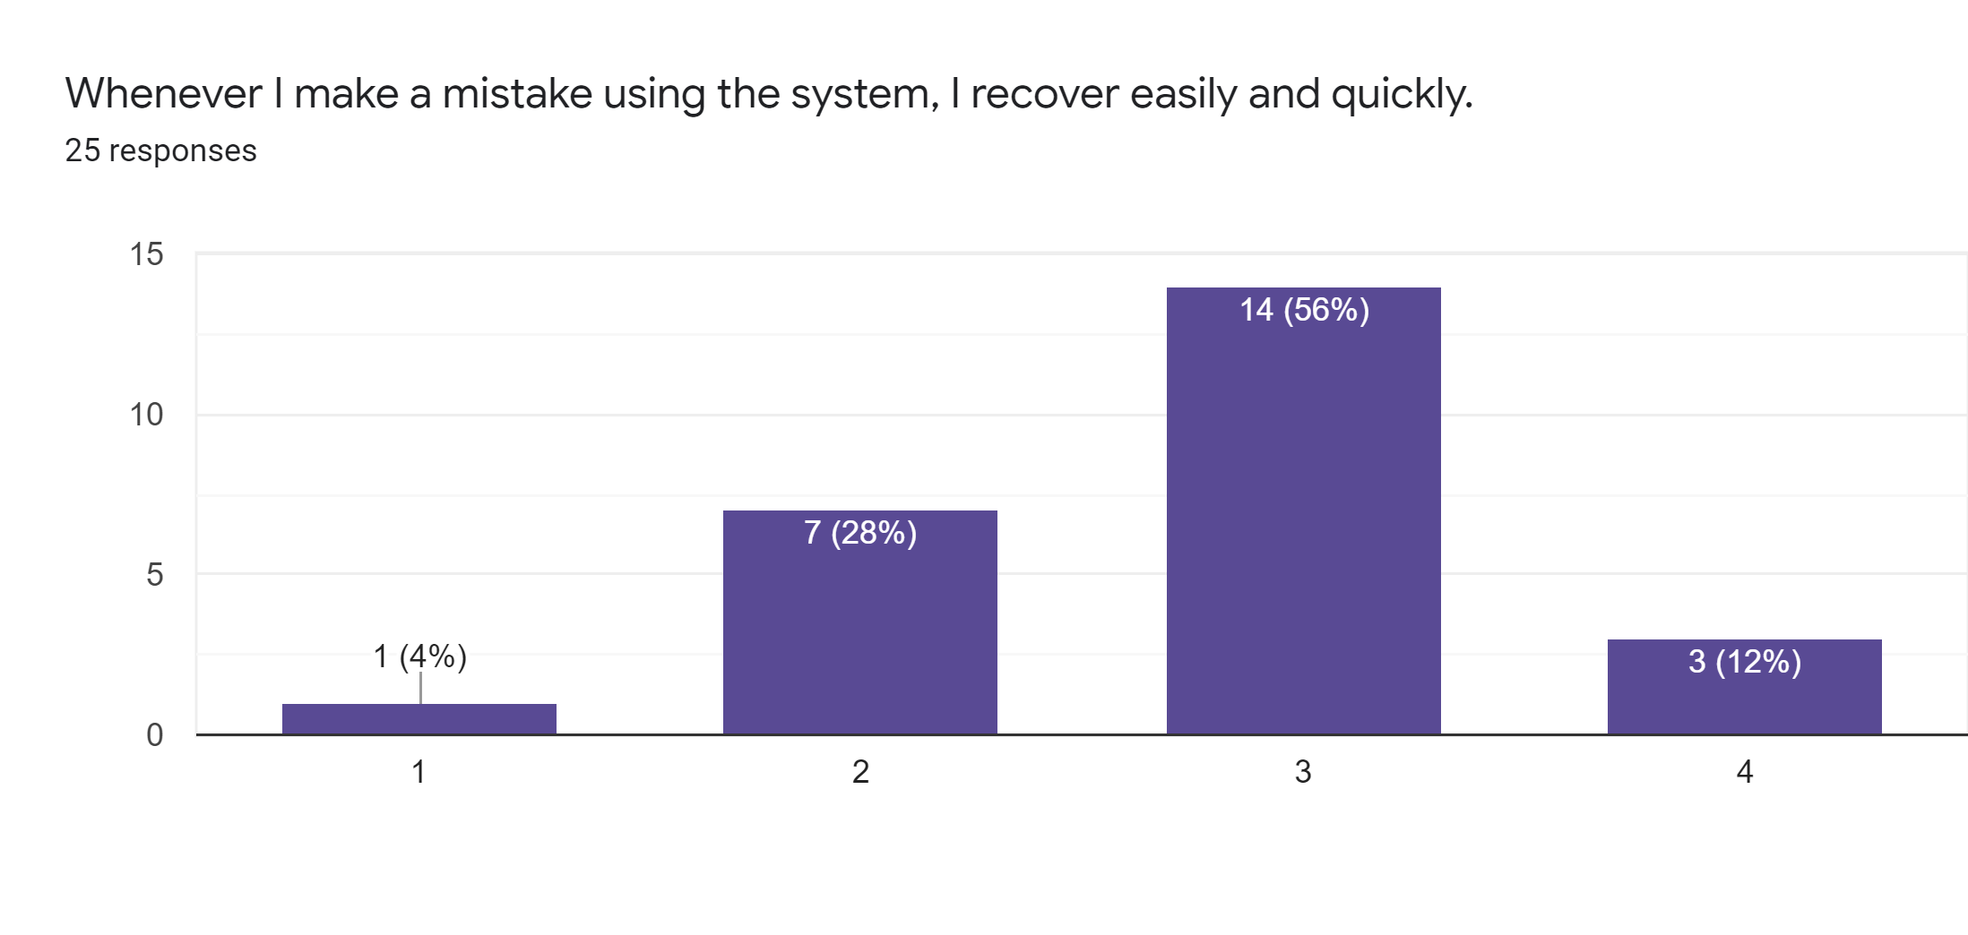

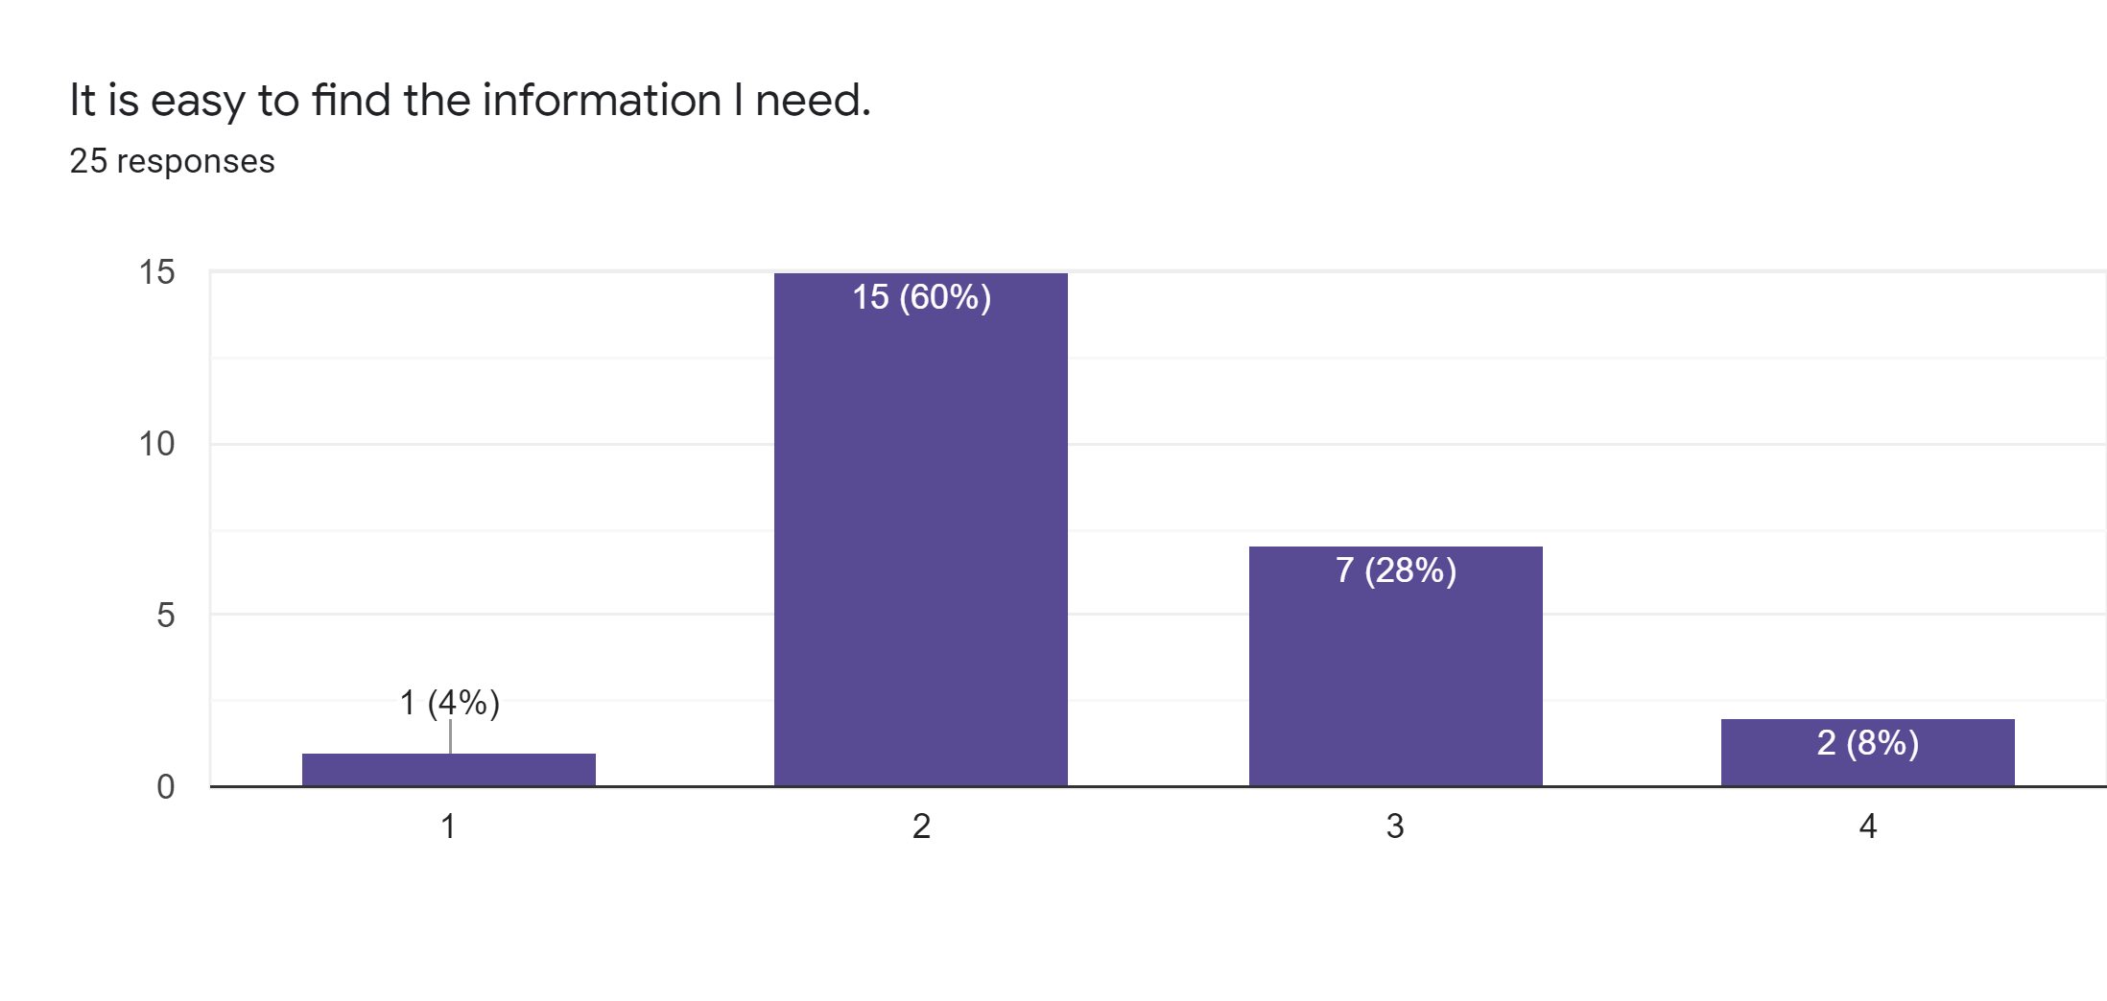

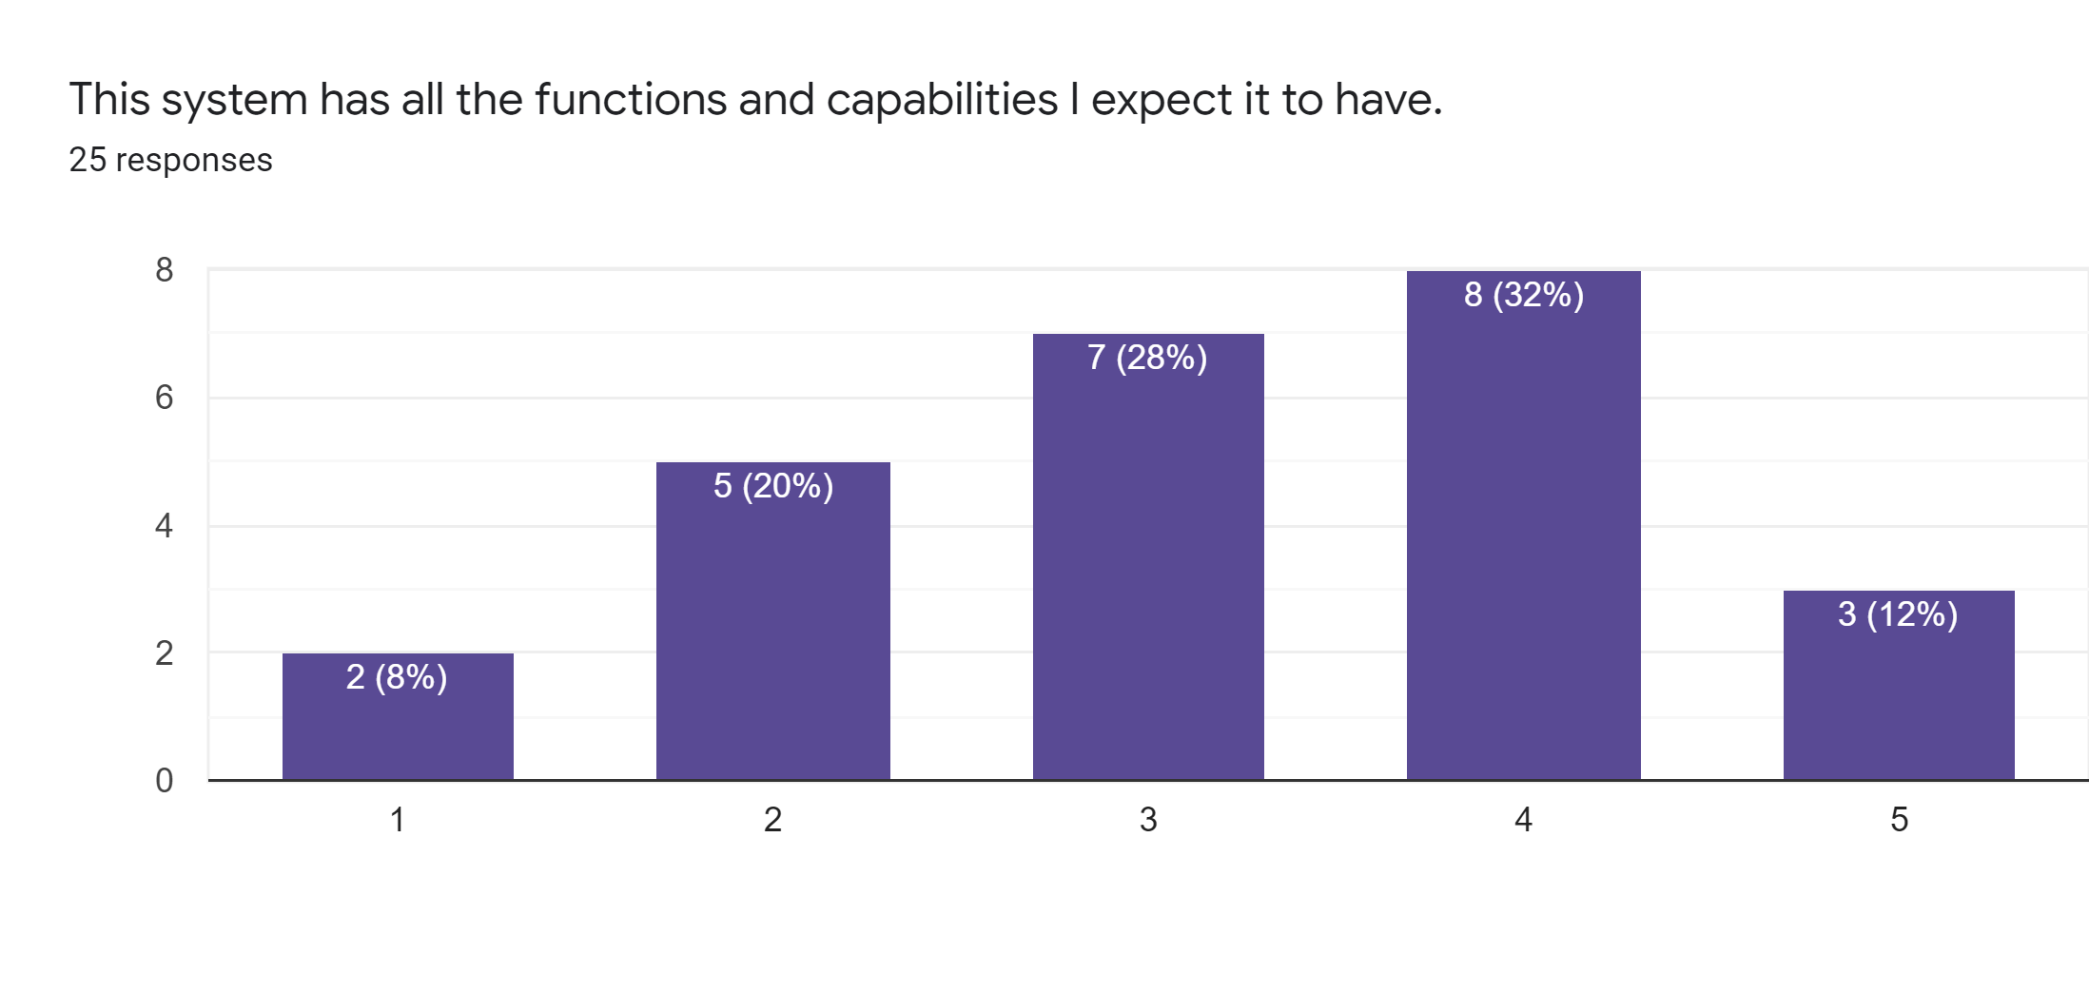

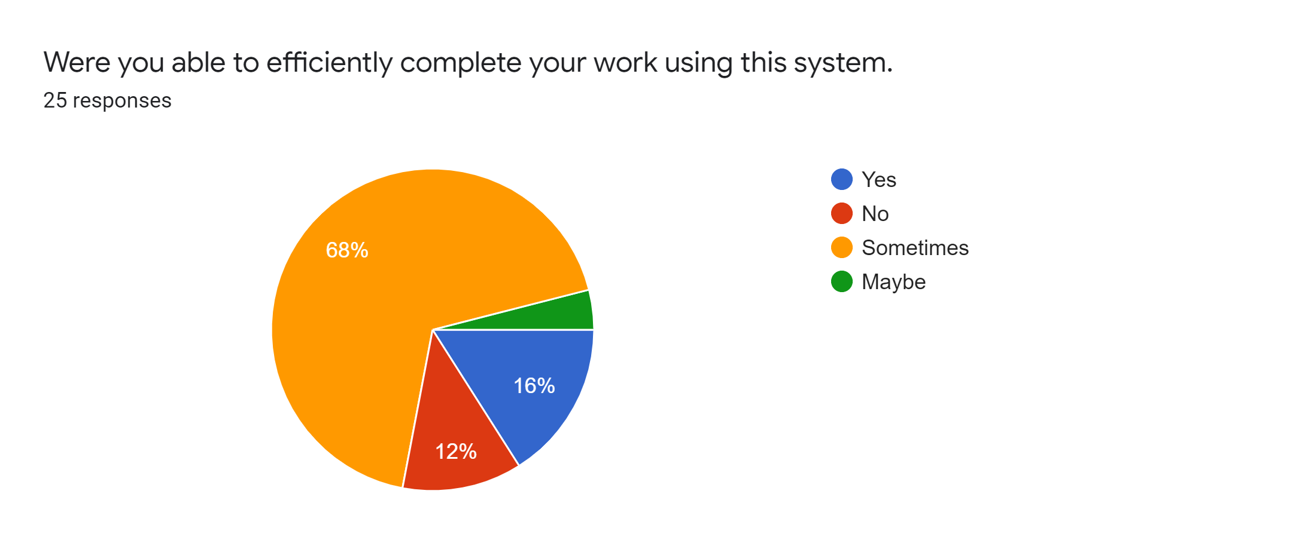

**Interview**

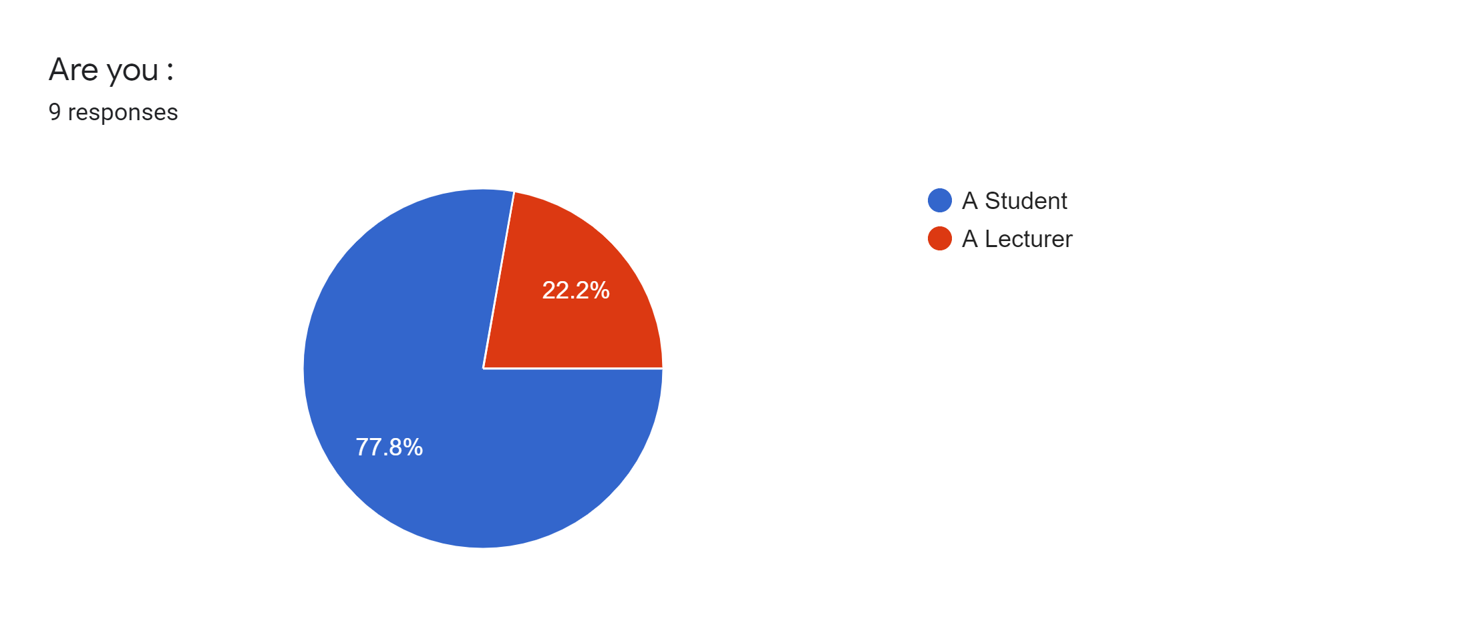

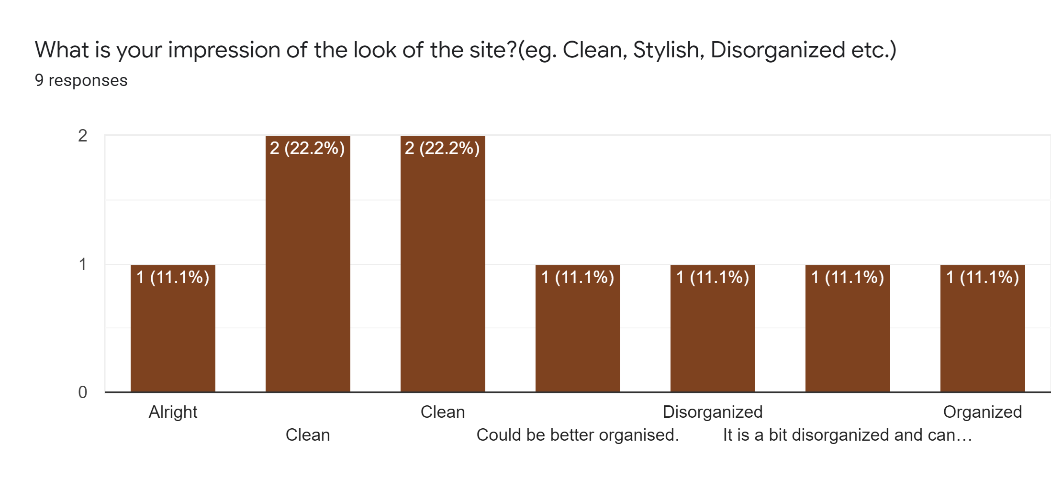

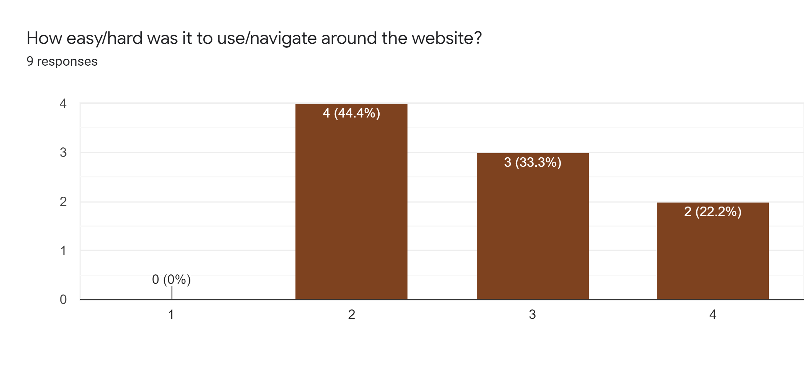

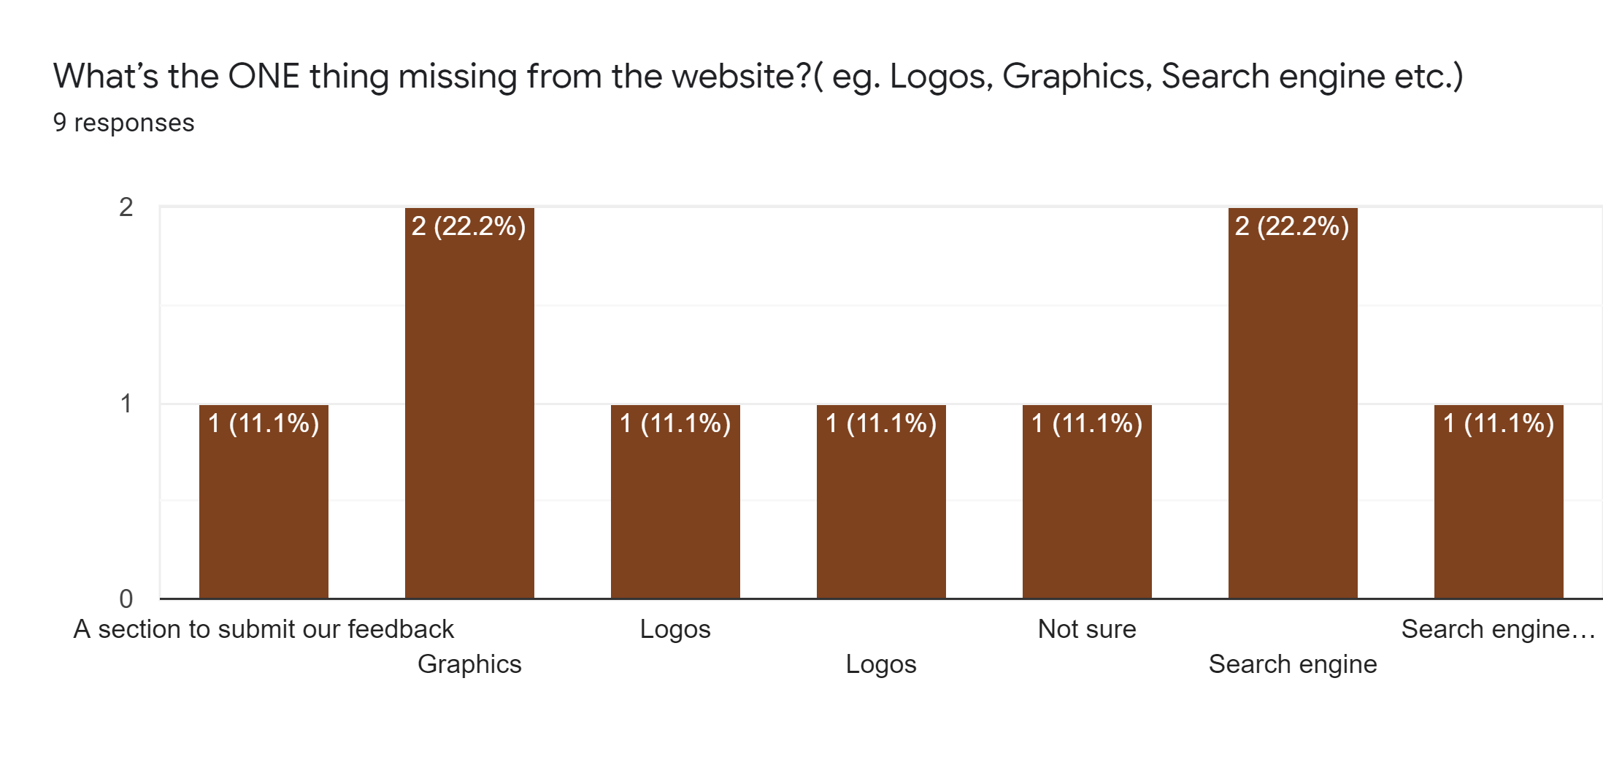

**Focus Groups**

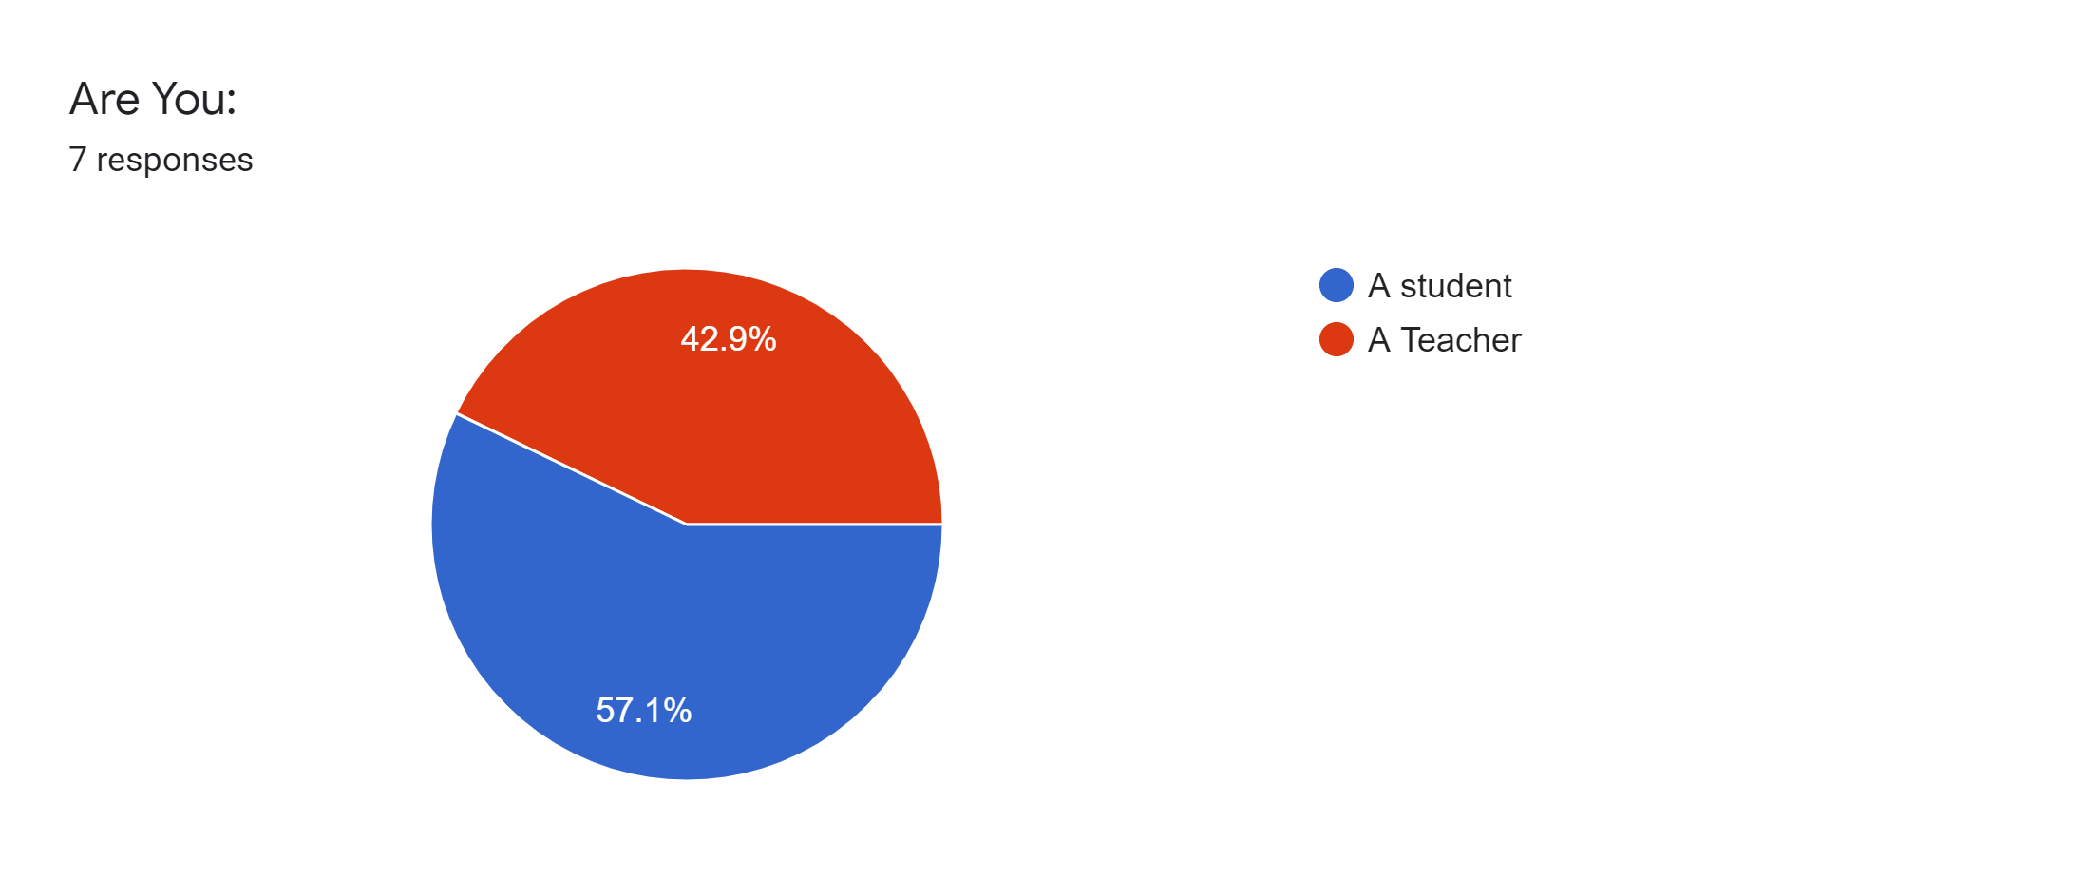

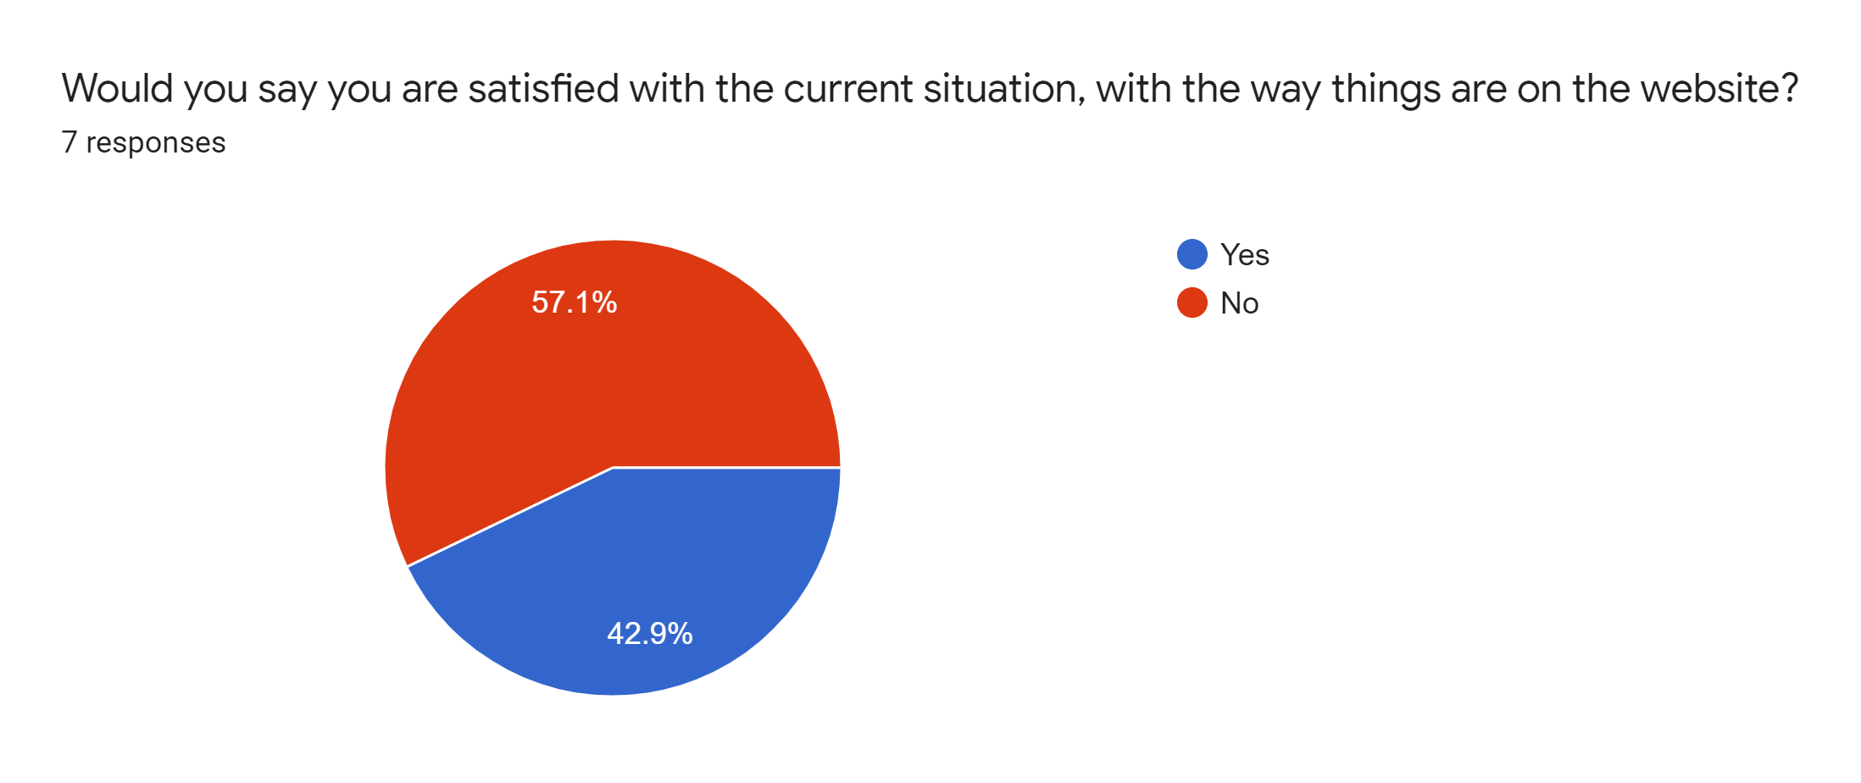

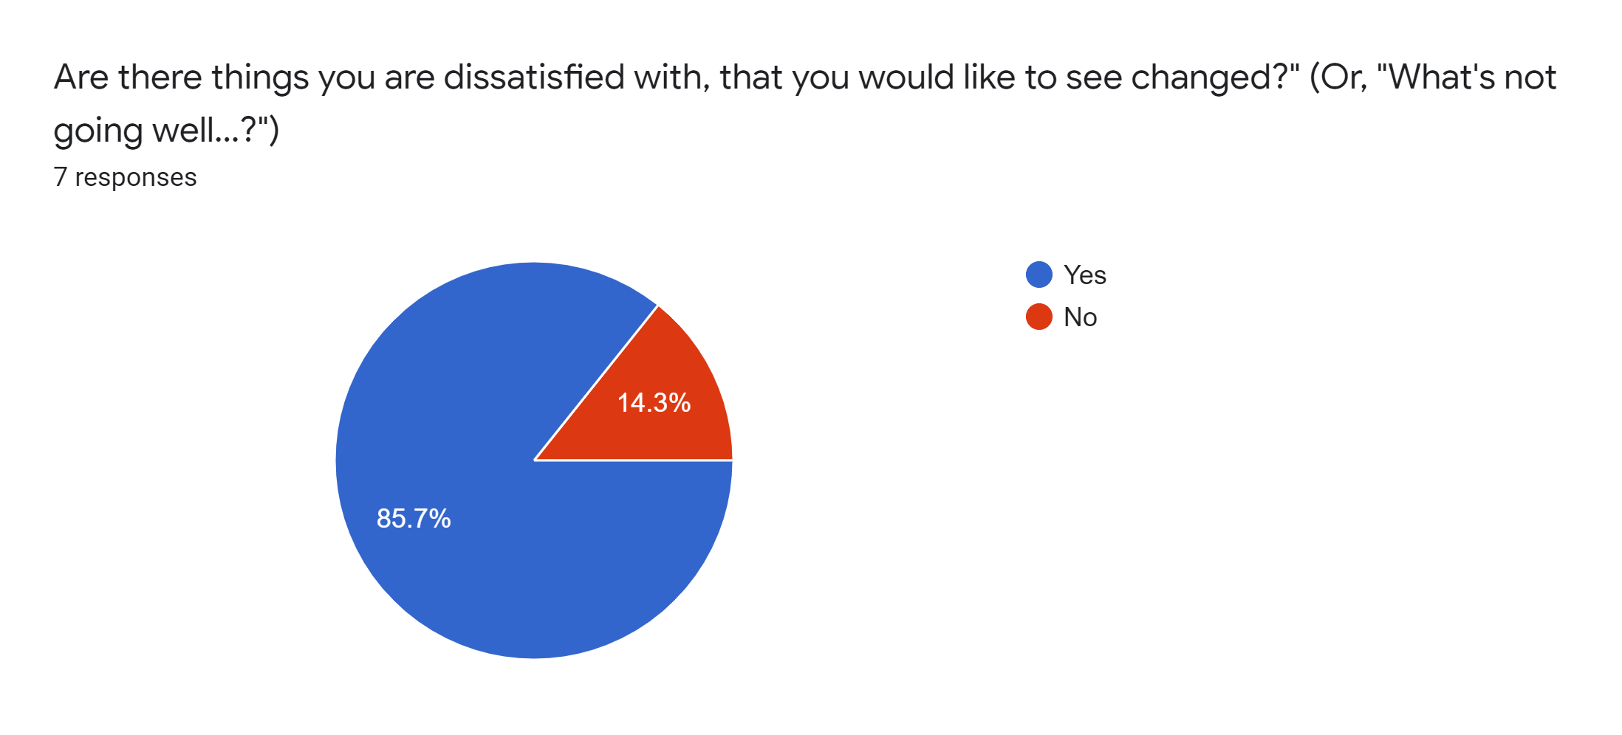

In order to effectively obtain the right data, we need to make sure that we already have valid collection criteria. For this reason, when doing a study, we need to take into account whether it is authentic or heuristic, empirical or deductive so that we can get our research to carry fully reliable results. Finally, the data collection tools must fit the analysis target. Interviews, focus groups and questionnaires were used. For the focus group, questions were posed in the seven-person WhatsApp group, 42.9 percent are teachers and 57.1 percent are students, and it took about 58 minutes to explore and collect all the answers. Data was placed into the google forum to create maps and to get all the short answers together. One key point of this focus group was that if there was something they were disappointed with, 85.7 percent said yes and 14.3 percent said no. If they said yes, each person would have to state the kind of things that they would like to alter. Much of the feedback was that how information is structured on the web is not very user-friendly. Another pointer they made is that it would be much easier if a search bar was presented on the Home Screen so that users would find their courses more quickly than perform a lot of extra work.

Concerning the surveys they were both conveyed by all gathering individuals, This poll comprises mostly understudies we have gotten 25 reactions 52% male and 48%are female, all both comprehensive of 92% students and 8% are teachers. 96% of respondents are 18-30 years of age and 4% are more than 30 years of age. Another inquiry that populates did you discover the data you were searching for on the site Utech moodle 48% of respondents said yes, 32% said once in a while and 20% said no. Our next inquiry was how frequently do our respondents use moodle? 68% said regularly, 20% frequently and 12% sometimes. We at that point asked our respondents that depending on their latest experience, what is their general fulfillment with the Utech moodle site? 52% reacted were unbiased 20% disappointed 16% fulfilled 8% exceptionally disappointed 4% very satisfied. The interface of this framework is lovely 40% concur, 32% dissent, 16% firmly differ and 12% emphatically agree. Each respondent was asked that at whatever point they commit an error utilizing the framework, do they recuperate effectively and rapidly 56% deviate, 28% concur, 12% unequivocally differ and 5% unequivocally concur. The next inquiry was if It is not difficult to track down the data they need 60% to concur, 28% deviate, 8% unequivocally differ and 4% emphatically concur. The respondents were inquired as to whether the framework has all the capacities and abilities they anticipate that it should have 20% concur, 32% deviate, 12% unequivocally differ and 12% emphatically agree. Finally, the respondents were inquired as to whether they had the option to productively finish their work utilizing the framework 72% said some of the time, 16% said yes and 12% said no.

At last concerning the interviews which comprised 9 reactions 77.8% are students and 22.2% are teachers. While leading a meeting we understood that two fundamental inquiries have a similar measure of reactions for one of the inquiries which states on the off chance that they could at this point don't utilize the site what might they miss the least, most reacted that they will not miss the nonstop accident of the site. Another inquiry that was posed was the one thing missing from the site? 33% expressed search engines and 22% said designs.

**User Model**

**UTech Online 2.0**

USER ROLE MODEL - FORM S6

**FOCAL ROLE (Check)**

**Identifier. Name: Students, Lecturers, Software Developers,**

**OVERALL RESPONSIBILITIES (of person in the role):**

Students: To get access to course information on the system.

Lecturers: To provide the students with course materials.

Software Developer: To design, develop and test the software application.

System Administrator: To maintain and monitor the performance of the system.

**SPECIALIZES:**

**INCLUDES:**

**OTHER RELATED ROLES (PRECEDES, SUPPLIES, etc.):**

**GENERAL CHARACTERISTICS (narrative description): ____ unknown _____ not applicable**

|  |  |
| --- | --- |
| **SALIENT BACKGROUND (training, education, experience, background, sophistication, intelligence, etc.): ✓ unknown _____ not applicable** | |
| **DOMAIN KNOWLEDGE: ____ unknown ✓ not applicable**  **__ low __ medium __ high** | **SYSTEM KNOWLEDGE: ____ unknown _____ not applicable:**  **__ low ✓ medium __ high** |
| **PROFICIENCY PROFILE: ____ unknown _____ not applicable**  **____ % low/novice ✓ % medium/intermediate ____ % high/expert** | |
| **INTERACTION PROFILE: ____ unknown _____ not applicable __ ✓ required __ discretionary frequency: __ low __ medium ✓ high ✓ predictable __ variable __ unpredictable __ irregular ✓ regular intensity (rate): __ low ✓medium __ high ✓concentrated (batched) __ distributed ✓ continuous __ discontinuous total volume: __ low __ medium ✓ high __ simple ✓moderate __ complex __ process-driven ✓ user-driven** | |
| **INFORMATION PROFILE: ____ unknown _____ not applicable dominant flow: __ from user __ to user ✓balanced origin: __ aural input __ visual input __ mental process __ telephone __ paper __ other: ________________________________________ available information volume: __ low __ medium ✓high __ very high**  **data complexity (elements, groups, data types, sources, etc.): __ low __ medium __ high ✓ very high** | |
| **SUPPORTING CAPABILITIES (special needed functions, features, or facilities): ____ unknown _____ not applicable**  **Advanced search features that are present on the home for students to locate the course effectively and efficiently** | |
| **USABILITY OBJECTIVES (rank or check): ____ unknown _____ not applicable**  **✓ efficiency ✓ accuracy ✓reliability ✓learnability ✓rememberability ✓user satisfaction ✓clarity ✓ comprehensibility ✓ attractiveness __ other: ________________________________________** | |
| **OTHER SALIENT ROLE FEATURES OR CHARACTERISTICS: ✓ unknown _____ none** | |

**Task Model**

**Use Case Diagram**

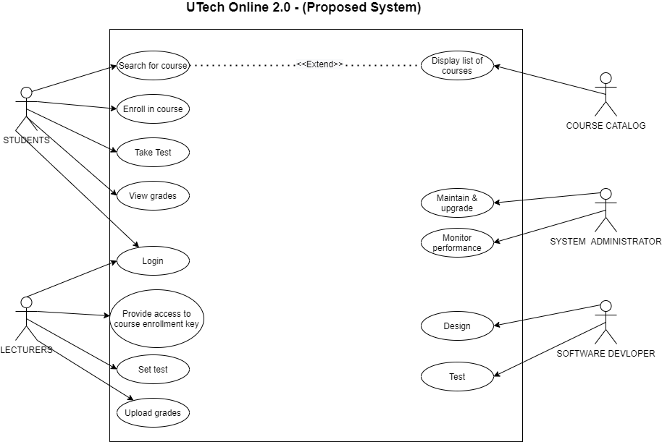

**Claims Analysis**

What features of the current situation are desirable and should be kept?

* Some features that are highly preferred, useful and users want them to be carried over to the new system are compatibility features with BlackBoard Collaborate and TurnItIn. The Schedule update feature where the calendar would inform students on upcoming assignments, tests, and so on.

What features are problematic? Record them in a Claims Matrix form. Also, if features of potential technology solutions were discussed in your data gathering, record them and their pros and cons here. This potentially informs all types of requirements.

* Problematic features include the search bar and the majority of the user interface’s design.

**The Requirements:**

This page will have a subsection for each category of the requirements (data, functional, environmental, user, usability). Under each category, provide links to pages stating the requirements (one page per category, based on the Template). The Origin field of these requirements pages in turn link to the foregoing analyses or data as needed.

# **Data Requirements**

* Post Resources.
* Display lesson plans.
* Publish class schedules.
* Communicate directly with students/lecturers.
* Share news and announcements for modules.
* Provide resource links.
* Create a class calendar.

# **Functional Requirements**

The functional requirement would define a specific operational behavior the system should possess when the requirements are met.

* Advanced search features: To alleviate the issue of discovering the data that have been searched for on the site Utech moodle 32% said once in a while and 20% said no.
* Administrative functions
* Authentication
* Authorization levels
* External Interfaces
* Certification Requirements
* Reporting Requirements

# **Environmental Requirements**

Environmental requirements restrict the impact that the external environment (natural or induced) may have on the system and the effect that the system will have on the external environment.

* Availability
* Capacity, current and forecast
* Certification
* Compliance
* Compatibility of software, tools, standards, platform, database, and the like
* Disaster recovery
* Failure management
* Maintainability

# **User Requirements**

The User Requirements Specifications are a valuable tool for ensuring the system will do what users need it to do.

* Accessibility
* Accuracy
* Backup and restore
* Concurrency
* Configuration management
* Dependency on other parties
* Deployment
* Documentation
* Efficiency (resource consumption for given load)
* Effectiveness (resulting performance in relation to effort)
* Error handling
* Extensibility (adding features, and carry-forward of customizations at next major version upgrade)
* Performance/response time
* Price
* Privacy
* Portability
* Quality
* Recovery/recoverability
* Redundancy
* Reliability (e.g., mean time between failures – MTBF)
* Reporting
* Resilience
* Resource constraints (processor speed, memory, disk space, network bandwidth, etc.)
* Response time
* Robustness
* Stability
* Safety

# **Usability Requirements**

## **Consistency throughout Mobile/Smart Devices**

Developing a Responsive Design. Because more and more people use their smart devices to access the Internet, it has now become important to build a mobile website that is optimized. The first move is to verify if your current website looks on your mobile screen.

## **Accessibility**

A user-friendly website can also be open to everyone, including the blind, disabled or elderly. Usually, these people use screen-readers to navigate the Internet. Illustrating a user-friendly website relies on basic web design methods that can be used to guarantee that your website can be quickly viewed by on-screen readers, rendering the website accessible to a broader audience.

## **Well Planned Information Infrastructure**

The arrangement and display of information on your website are important for successful usability. It has now become even more relevant as websites provide a wide variety of information and services to attract their target market. Plan the website pages and categories carefully and show information in a manner that is easy for visitors to identify. Often look from the point of view of the users. This is especially relevant if you are delivering a lot of material on your company's website.

## **Well-Formatted Content That Is Easy to Scan**

The website should have good Good Formatting. The average Internet user skips over the text of a new website rather than reading every word from top to bottom. Users appear to search through the main sections of the website rapidly to decide if they are important to their needs.

It's imperative to structure your content with this in mind. The right use of headings, sub-headings, articles, bullets or lists helps to break down text, making it easy for readers to scan.

## **Quicker Loading times**

Speed is an important factor to consider when reconstructing a website, because what is more irritating for website users than a website that takes a long time to load. In reality, slow speed is one of the key reasons why users are leaving the website. Customer standards have shifted dramatically in recent years. Typical users will only wait only a few seconds for your website to load, after which they will most likely switch to a competitor's webpage to never visit again. Ensuring that your site loads within 4 to 6 seconds are essential for effective usability. It also influences the rating of the search engine.

## **Consistency of browser**

Browser consistency can easily be excluded. And the websites of some of the most respectable organizations are suffering from this dilemma due to negligence. It is terrible for branding which has a negative impact on the usability of the website. While modern browsers have advanced and become more powerful, there are still some discrepancies in how different browsers interpret the website. It is crucial to make sure that the website displays and performs reliably across popular browsers such as Chrome, Internet Explorer, Firefox, Safari and Opera. Basic details like this set an expertly built website apart from the rest.

## **Effective Navigation**

Good navigation is one of the most essential factors of a website’s usability. Tools such as Basic HTML or JavaScript widgets seem to function well and be compatible across all browsers and platforms. It is equally important for the navigation to be clutter-free. Try to limit the number of menu items as far as possible. A drop-down menu or sub-navigation may work better on a large site with many sections and pages.

There is more to navigation than the menu. Here are some other aspects to consider:

* Good search feature.
* Multiple ways to explore content
* Custom Error 404 Page.
* Good Internal Linking
* Informative header and footer
* Proper Error Handling